Assignment 1: Getting Started
Introduction
This assignment was to equip me with the basics of professional software development in Python, Visual Studio Code (VS Code), and GitHub. Creating the right development environment is the essential preliminary step to the implementation of algorithms, source code management, and version control. To develop the project, it was necessary to install Python, set VS Code as an Integrated Development Environment (IDE), create a GitHub repository, and write the Insertion Sort algorithm that will put data in monotonically decreasing order. The assignment indicates that I have mastered the concepts of algorithmic design, setting up the environment, and the maintenance of source-codes both in academic and real-world settings.
Python Installation and Setting up.
Python was chosen due to its readability, simplicity, and availability of a wide range of libraries which allow performing algorithmic analysis and scientific computing. The official Python Software Foundation site (https://www.python.org/downloads) was used to install the latest Python. The installation option of adding Python to PATH was used to make sure that the interpreter is accessible in the terminal or command prompt. The environment was checked after installation with:
python --version
The anticipated output ensured that it was properly set up. This is an important stage of verification to avoid environment-path errors, which may stop the execution.
Dynamic typing and interpreted language enable Python to be used in prototyping algorithms. Besides, it supports data structures like lists and dictionaries, making it straightforward to execute algorithms on theoretical pseudocode, and this is demonstrated in Introduction to Algorithms (Cormen et al., 2022).
Visual Studio Code Setup
This was followed by the installation and configuration of Visual Studio Code (VS Code), which is a lightweight and powerful IDE but supports several programming languages. The installer was obtained (downloaded) on the following webpage: https://code.visualstudio.com/, and it was executed with the default settings. However, once VS Code has been launched, there were two important extensions which were added using the Extensions View:
- Python Extension (Microsoft) - Code linting, IntelliSense (auto-completion) and debuggers.
- Code Runner Extension – This provides the ability to execute the scripts quickly in the editor.
Python interpreter was installed through the Command Palette under Python: Select Interpreter by verifying the correct version. A project folder was created, named as MSCS532_Assignment1, and then a new file, that is, a Python file, was created and named as insertion_sort_descending.py.
In order to execute a program in VS Code, the following approaches were experimented:
- Running the python file by clicking the Run Python File button in the built-in terminal.
- Viewing the output in the Output tab with the help of the Code Runner extension.

- Manual execution of the script through terminal instructions (insertion sort.py).
This configuration showed how VS Code can be flexibly used to test and debug.
GitHub Repository Creation
An account at GitHub was established upon the institutional email address, and a public repository called MSCS532_Assignment1 was created.
Incremental progress was demonstrated by three commits:
- Initial commit - Repository created and README.md file added.
- Algorithms commit -Implementation of insertion sort algorithm. The code of working insertion.py.
- Final commit- Assignment Report documentation including the screenshot of the results are added.
Having multiple commits is also a good practice in software engineering to maintain a history of the development process, ease cooperation, and allow one to rollback in case of something going wrong.
Implementation of the Insertion Sort Algorithm.
The algorithm was a variation of the technique of Insertion Sort that was presented in Chapter 2 in Cormen et al. (2022). Conventionally, the Insertion Sort sorts the elements in increasing order. In this assignment, the algorithm was adapted to give a monotonically decreasing sequence (i.e. largest to smallest).
Code Implementation
def insertion_sort_desc(arr):
for i in range(1, len(arr)):
key = arr[i]
j = i - 1
while j >= 0 and arr[j] < key:
arr[j + 1] = arr[j]
j -= 1
arr[j + 1] = key

data = [4, 3, 14, 7, 3, 6]
print("Original array:", data)
insertion_sort_desc(data)
print("Sorted array (decreasing):", data)
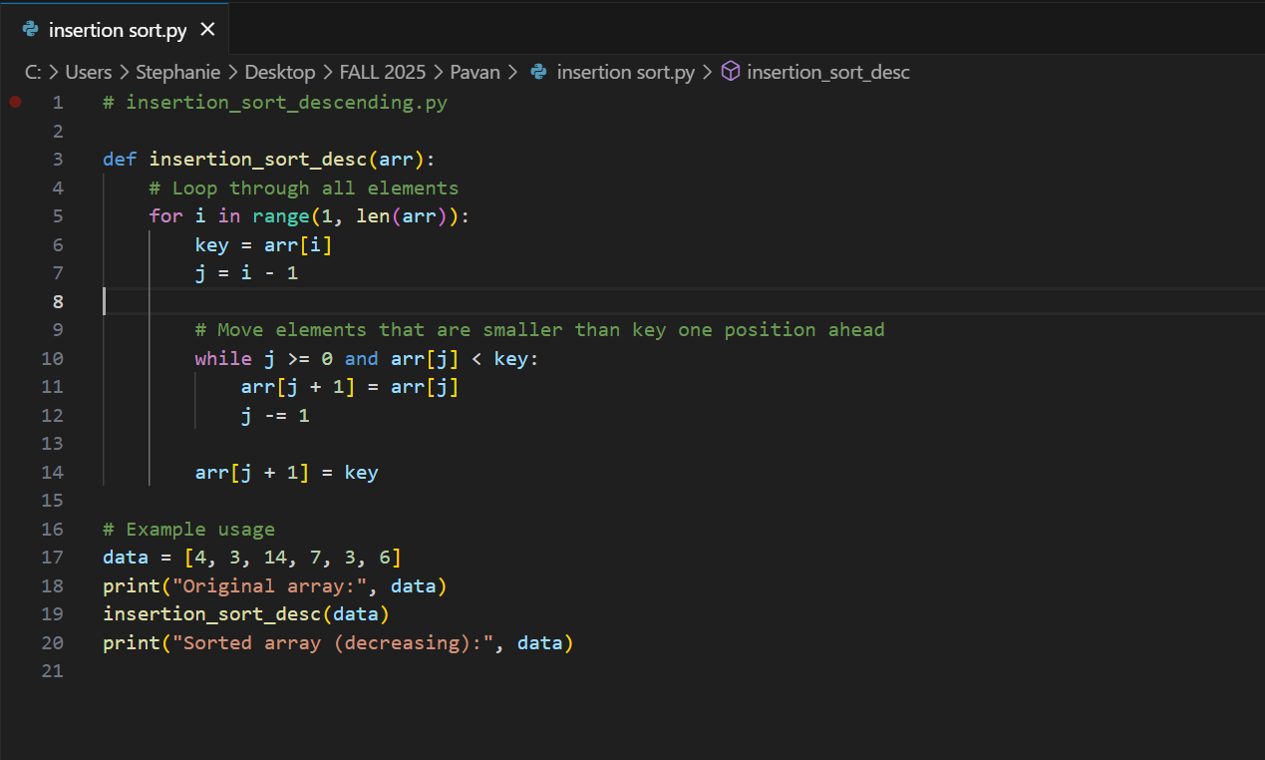
Explanation
The function repeats itself over the elements starting with the first index. All elements (keys) are compared with their previous elements, and smaller ones are moved to the right till the right descending position is identified. The resulting array is ordered in-place and without the use of an auxiliary list and O(1) space is kept.
Output
Original array: [4, 3, 14, 7, 3, 6]
Sorted array (decreasing): [14, 7, 6, 4, 3, 3]
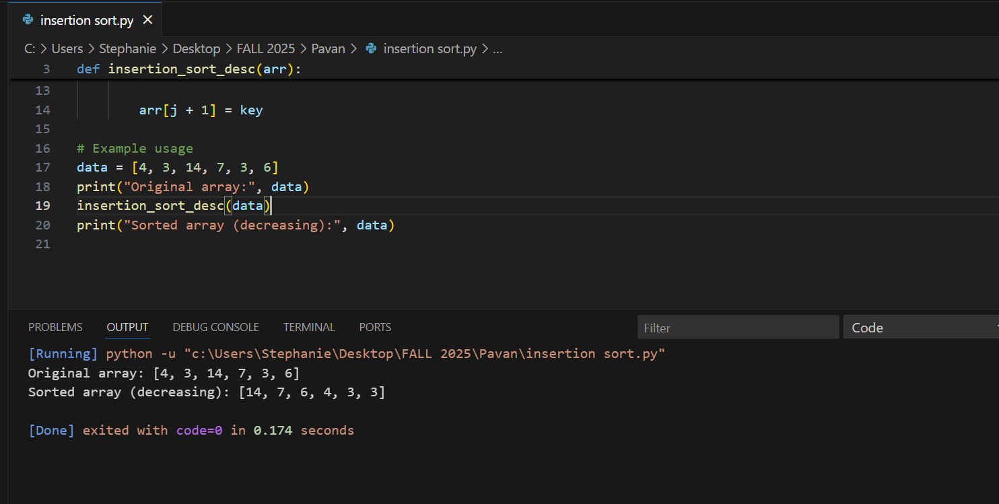
Various cases were tested in the program such as with empty arrays, duplicate values and already sorted data. The stability and correctness of the algorithm was proved to be correct across all inputs.
Results and Observations
The implementation of the algorithm in VS Code resulted in concistent and correct outputs. To demonstrate the flexibility of the algorithm, the downward variant of the Insertion Sort needed a slight adjustment, which was the change of the comparison operator. The workflow development demonstrated how the contemporary version control and IDE tools increase the productivity and minimize errors. Key observations include:
- Ease of Installation: Python and VS Code are cross-platform and configure quickly.
- Integrated Debugging: The terminal feature and debug feature of VS Code enabled quick testing without changing environment.
- Version Traceability: Git commits recorded the progress and provided a solid backup mechanism.
- Clarity in Algorithms: The step-by-step nature of the Insertion Sort was easy to visualize and check the progress at every iteration.
These results underscore the fact that well-organized workflow increases the program accuracy and programmer efficiency.
Challenges and Solutions
The first issue was to make sure that the system path acknowledged Python after installation. This issue was solved through the re-running of installer and the activation of the option of adding Python to PATH.
The descending order algorithm too needed to be debugged by critically reviewing the comparison operator (arr[j] < key rather than arr[j] > key). This modification helped in proper ordering and also avoided an infinite loop state.
Conclusion
The given assignment has been effective in exhibiting the complete procedure of establishing a software development environment, incorporating the latest features of the IDE, and controlling the source code with the help of GitHub. The Sorting Algorithm of the Insertion was developed and tested to check whether it works in the decreasing order. The experience increased Python syntax and algorithmic logic and version control concepts mastery. These abilities are a basis to more complex tasks of designing and analyzing algorithms during the MSCS 532 course.

Reference
Cormen, T. H., Leiserson, C. E., Rivest, R. L., & Stein, C. (2022). Introduction to Algorithms (4th ed.). Random House Publishing Services.

